1. The population growth of the world.

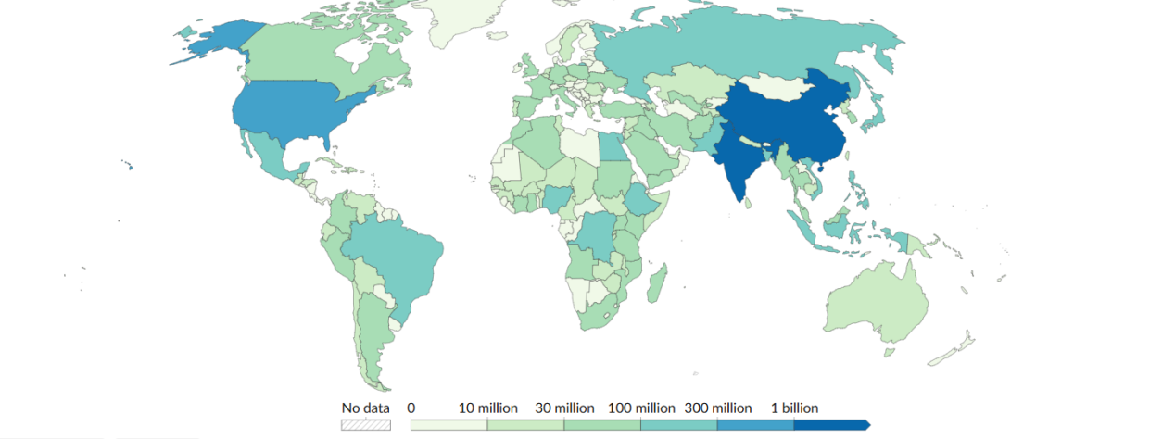

Data:HYDE (2023); Gapminder (2022); UN WPP (2024) – with major processing by Our World in Data

Cite:Hannah Ritchie, Lucas Rodés-Guirao, Edouard Mathieu, Marcel Gerber, Esteban Ortiz-Ospina, Joe Hasell and Max Roser (2023) - “Population Growth” Published online at OurWorldinData.org. Retrieved from: 'https://ourworldindata.org/population-growth' [Online Resource]

1. the population growth of China.

The population of China has been surging since 1949. the total number doubled in 70 years.

But will China keep growing its population in the future? When will reach the maxim?

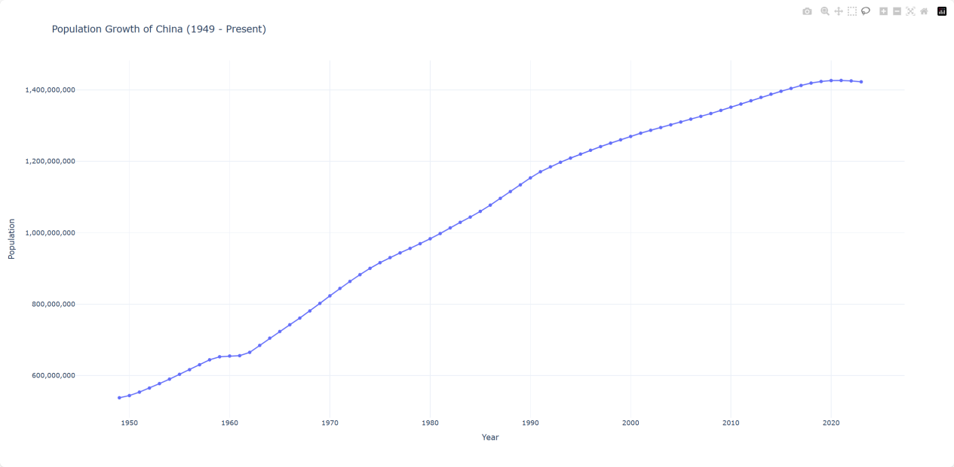

Data:HYDE (2023); Gapminder (2022); UN WPP (2024) – with major processing by Our World in Data

Cite:“Data Page: Population”, part of the following publication: Hannah Ritchie, Lucas Rodés-Guirao, Edouard Mathieu, Marcel Gerber, Esteban Ortiz-Ospina, Joe Hasell and Max Roser (2023) - “Population Growth”. Data adapted from PBL Netherlands Environmental Assessment Agency, Gapminder, United Nations. Retrieved from https://ourworldindata.org/grapher/population [online resource]

1. the annual growth of China

The data shows that the population of China has stopped growing since 2021 and it will continue to drop in the future according to the prediction.

Along the history, the population of China is influenced by multiple variables. But some historical events caused dramatic impact on it. For example, Great Chinese Famine in 1959 to 1961, which is regarded as the deadliest famine and one of the greatest man-made disasters in human history caused an estimated death toll due to starvation that ranges in the tens of millions (15 to 55 million). Also Culture Revolution from 1966 to 1976 slows down the growth of population.

Another relevant events is the one-child policy beginning at 1980, which restricted the birth of child.

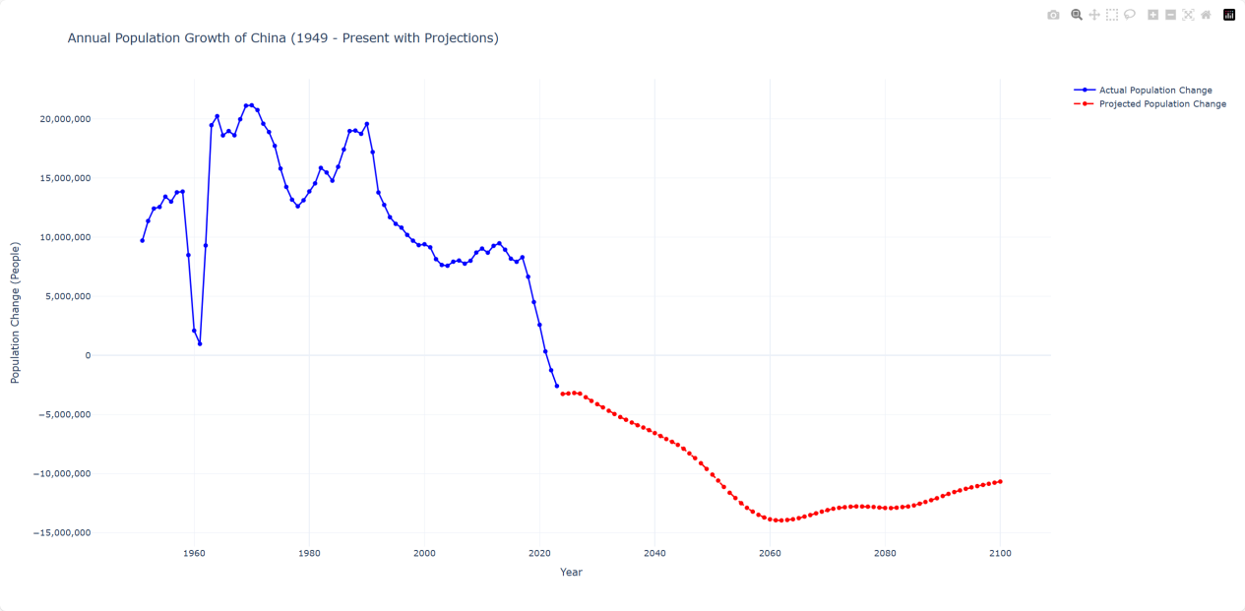

Data:Data:HYDE (2023); Gapminder (2022); UN WPP (2024) – with major processing by Our World in Data

1. It seem the growth rate has decreased dramatically since 2017, what happened in recent years?
   1. People in China are living longer but fewer babies are given birth to.

As we can see the life expectancy is raising steadily over the year and the death rate from all causes is also decreasing by year.

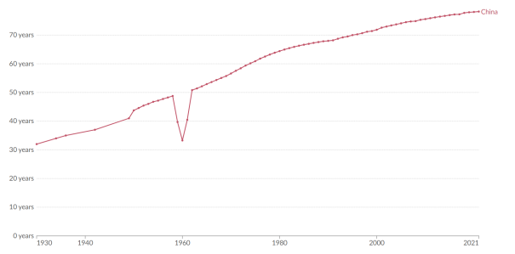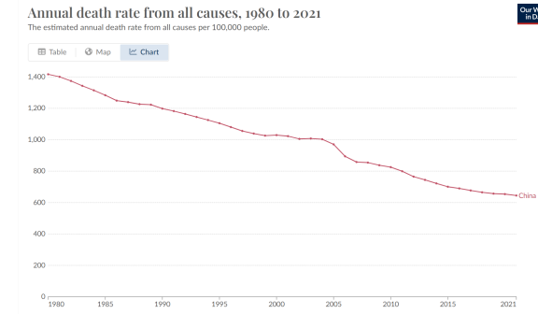

The reason why the population stop growing is that people are giving less and less birth to babies.we can see from the picture that there is a huge drop in birth rate since 2017, which decreases from 12.93% in 2017all the way to 6.26% in 2023 after the 20 years stable period from 2000s to 2017 which keeps a birth rate of 13%

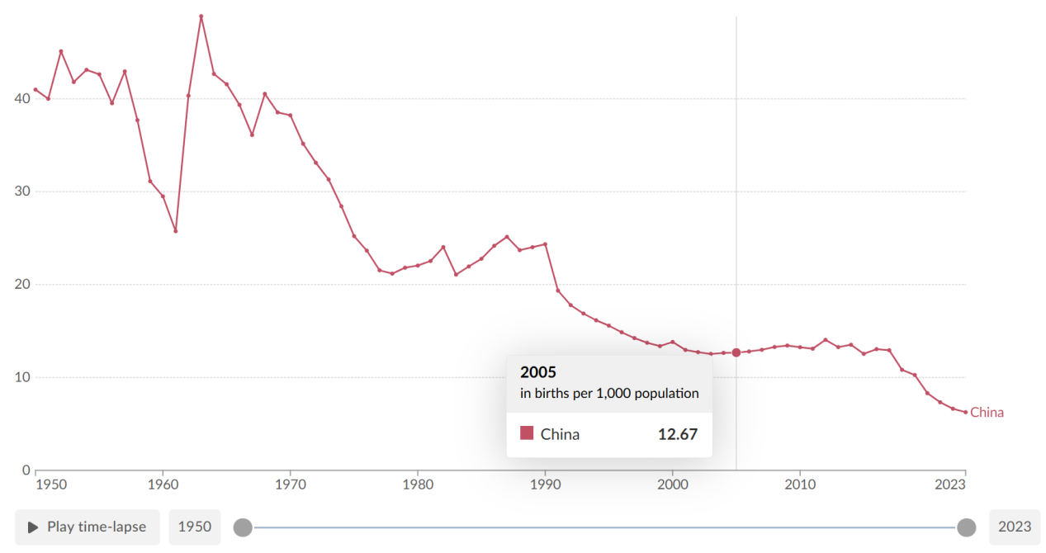

* 1. Why people in China just stopped giving birth to babies since 2017?

**4.2.1.People are unwilling to get marriage nowadays.**

The marriage registration shows a peak around 2013-2014, followed by a steady decline in recent years.although the divorce rate is decreasing at the same time, the fact is that less and less people get marriage.

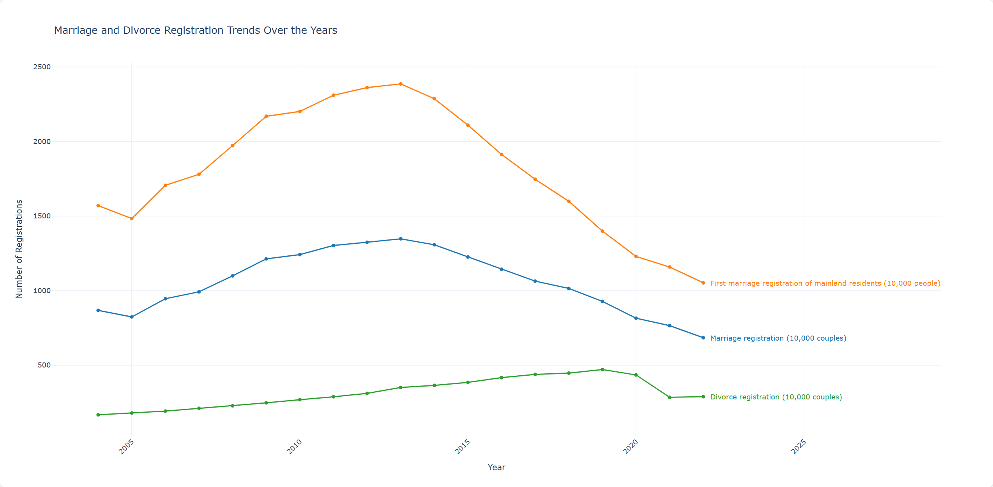

This results in more and more male and female of appropriate age stay single.

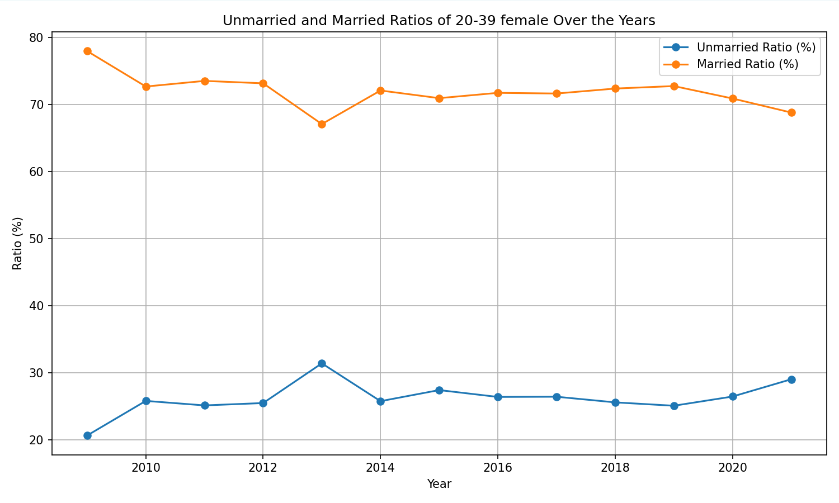

To go deeper, there **multiple possible reasons for the dropping marriage rate.**

First of all, **the total number of people of appropriate age has been shrink.** When we look at at the population Pyramid of 2022. I can find that population between 20-34, which is the appropriate age for female to give birth to babies is significantly smaller than the population age of 35-50, which is the last generation of appropriate age.

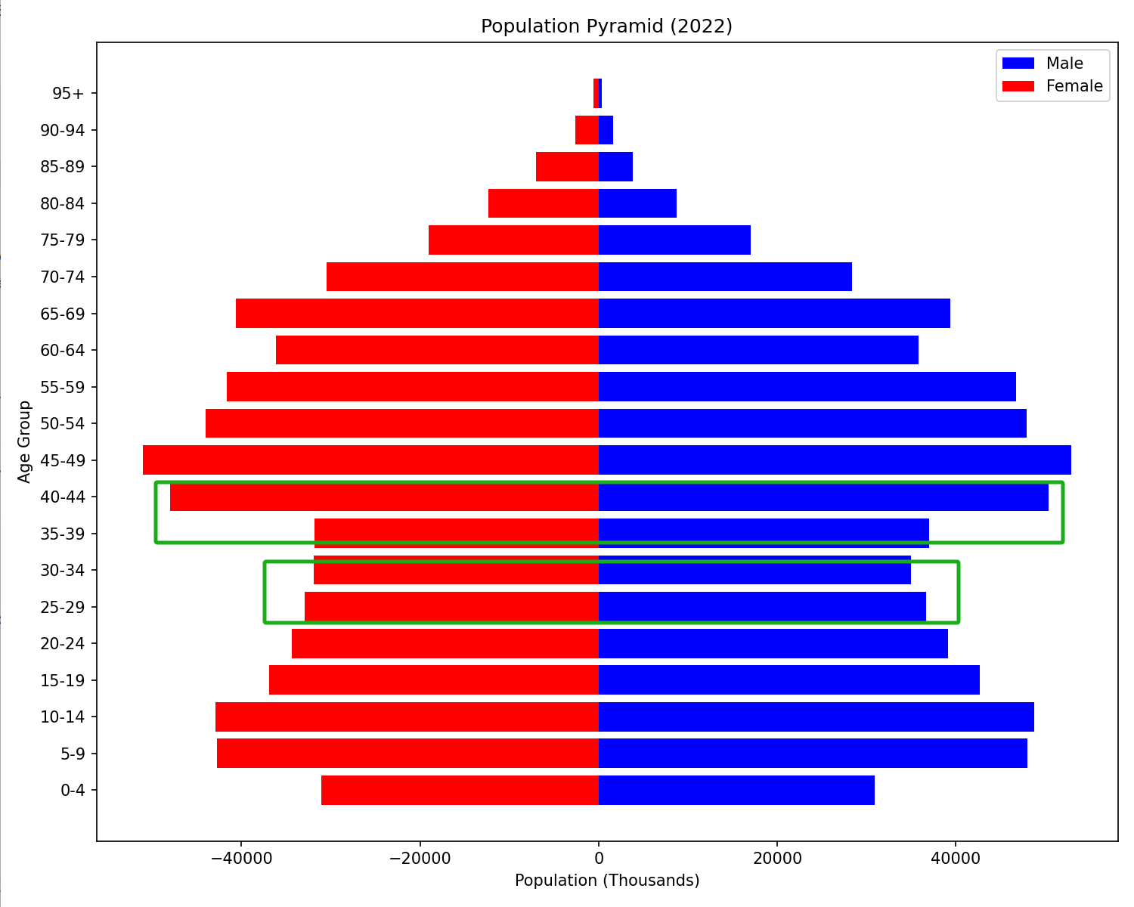

Second, **the age of first marriage is delayed over the year**. The following picture clarifies that male and female in China are getting marriage at later and later with the development of the society. The first marriage age surge rapidly since 2000s from 24 in average to 28 in average in 2020. The young people in China are postpone their first marriage and this results less marriage nowadays.

With the substantial improvement of women's education level and economic independence in recent years, the marriage concept of the younger generation has changed. Compared with their parents, more and more young people regard being single as a normal life choice. "Not getting married in your 30s" is no longer uncommon among young people.

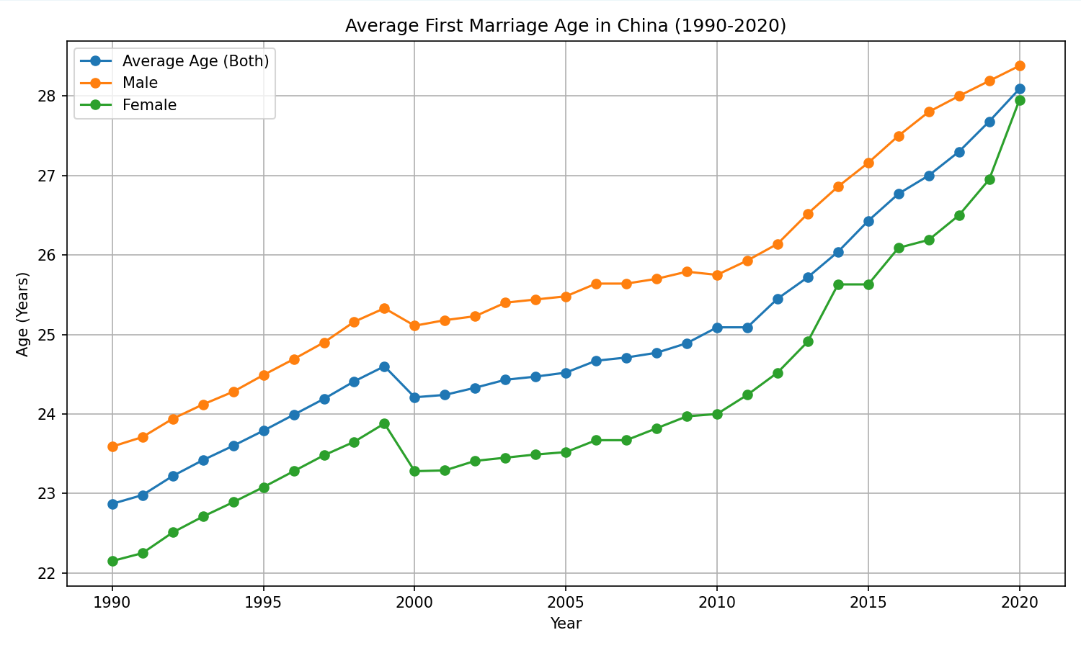

The **third point is that the high housing price in the cities and high betrothal gifts in rural areas makes marriage difficult for young adults**.

The following picture shows the house price to Income Ratio of urban citizen.

Where

As we can see, the price to Income Ratio has been raising rapidly since 2015 and became stable in 2020 due to the fluctuations in the real estate industry. According to 2021 National House Price to Income Ratio Report, “the national housing price to income ratio is in the reasonable range of 7.0-7.5, below 7.0 is in the low range, and above 7.5 is in the high range”, which means the urban citizens suffer from massive pressure of house price. AS a result, the high price of house inhibit young adults to get married.

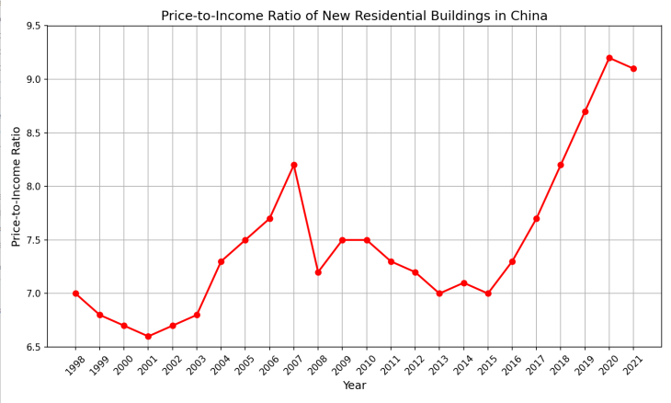

Despite China’s rapid economic growth in the past, wage increases have not kept pace with the rising cost of living. Many young couples do not feel financially secure enough to raise a child, let alone multiple children.

4.2.2. the Chinese family is also shrinking.

To notice this, we draw the trend of the number of children per woman In China comparing with the world and Singapore. We can see an obvious decline at 2017 from 1.8 to 1.0 in 2023.This mean the size of family is getting smaller and smaller in recent years.

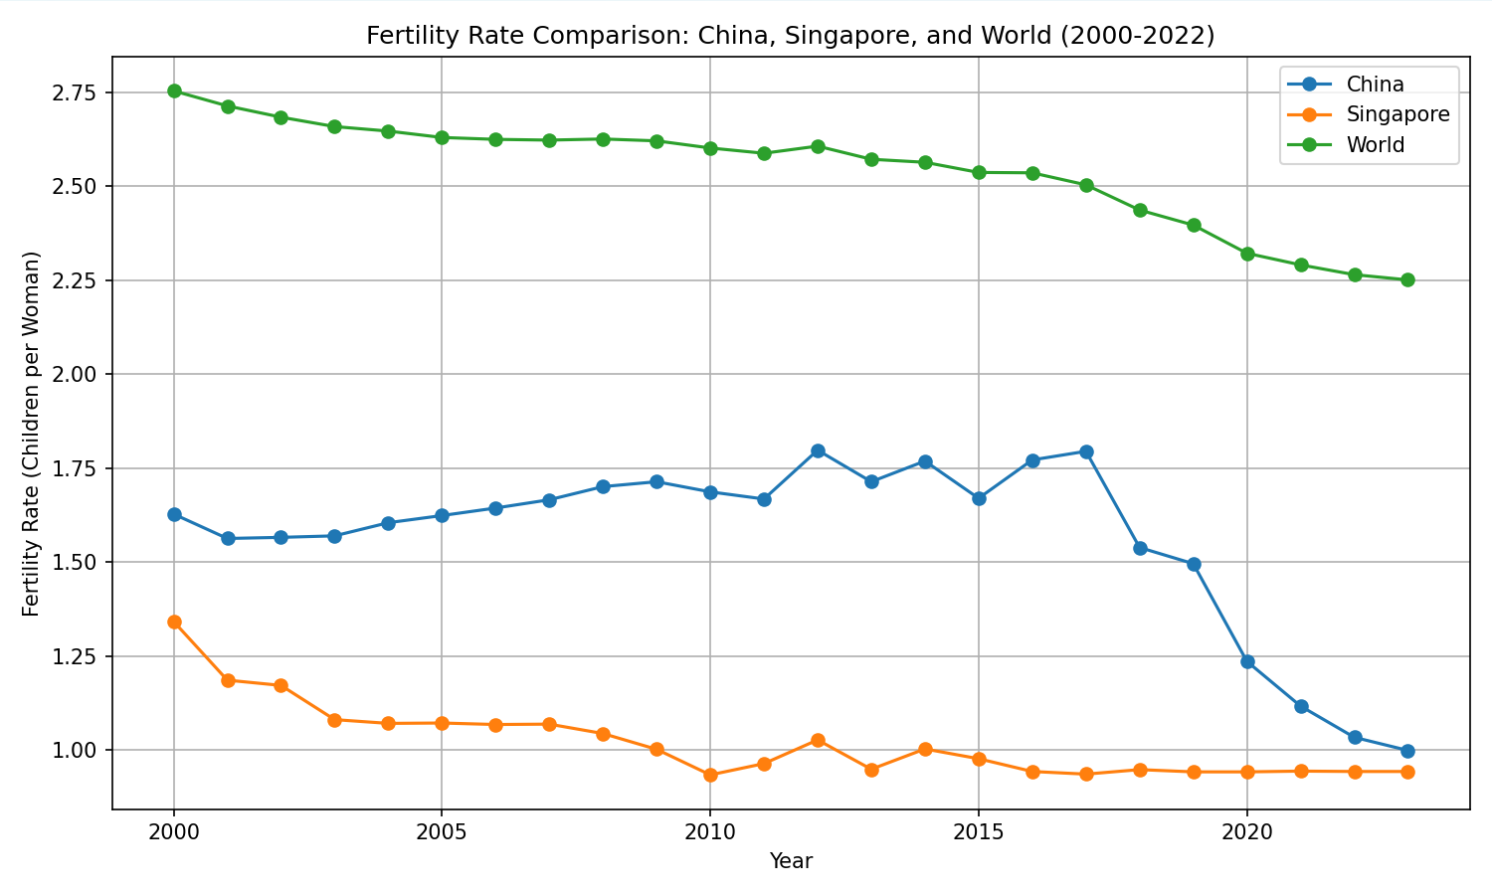

Cite:Max Roser (2014) - “Fertility Rate” Published online at OurWorldinData.org. Retrieved from: 'https://ourworldindata.org/fertility-rate' [Online Resource]

Again, reason behind it is complicated but we can consider it in the following aspects.

**The Childcare costs is high.**

According to the China Fertility Cost Report 2024,The top reason why women of childbearing age do not plan to have more children is "heavy financial burden".

So what is the actual cost of childcare?

From the donut chart below, we can see the average cost of child-raising from 0 to 17 is over 500,000 yuan, which is way beyond the average annual income of Chinese citizen.

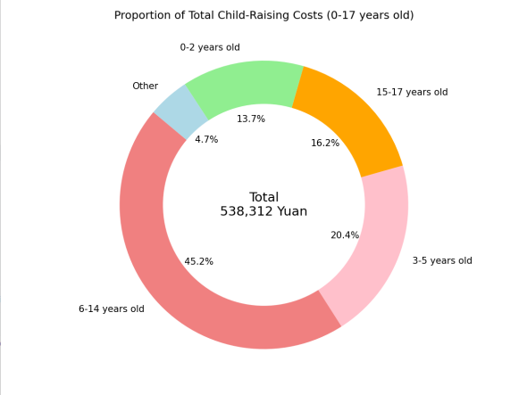

This number is even higher in urban area and big cities. We can see in Shanghai and Beijing, the total costs of childcare is nearly double the National average cost, which makes young adults working unlikely raise children in these cities.

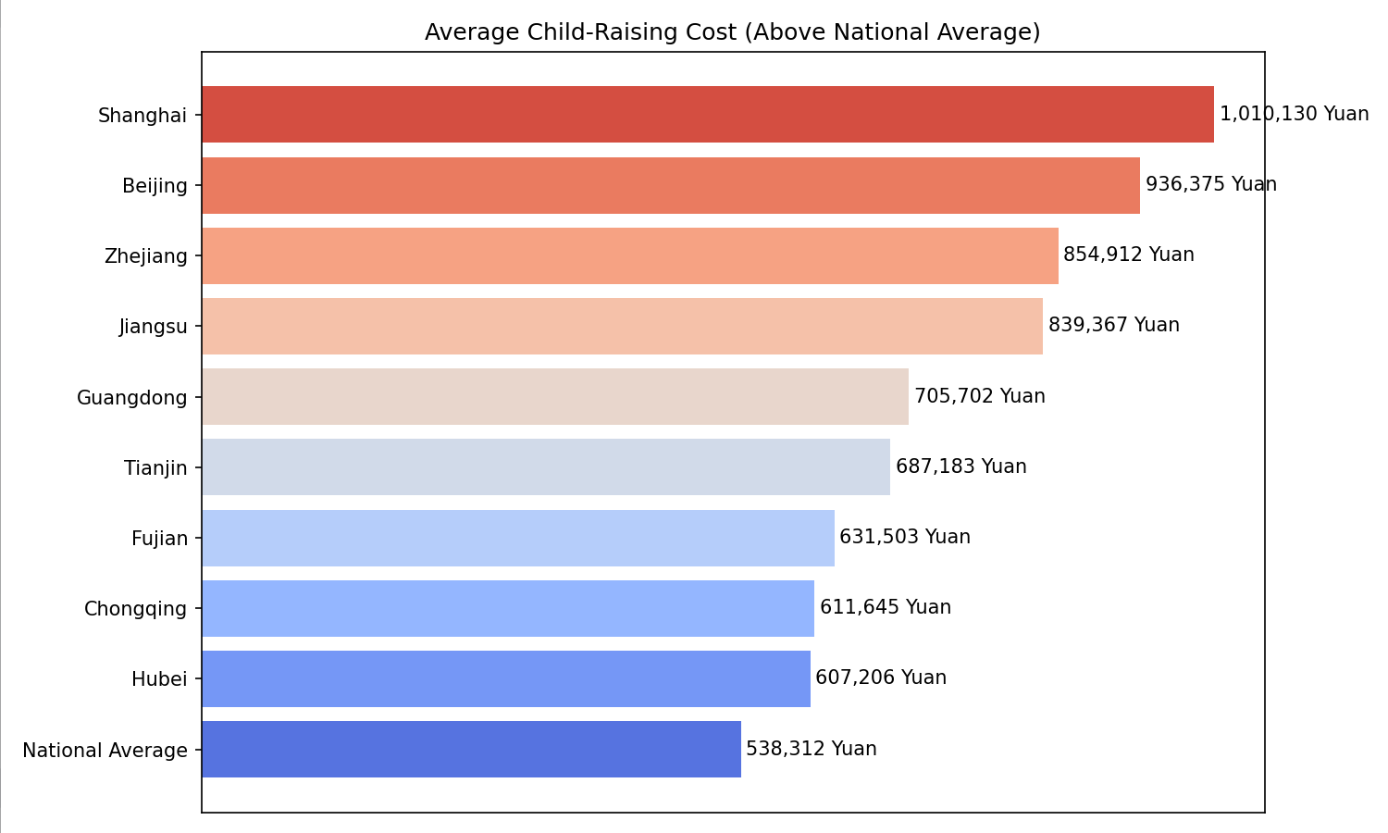

Chinese citizens has huge burden raising a child compared to other countries. The following picture denotes the ratio of childcare cost and GDP per Capita in some countries, which is represented by the size and color of scatters. What we can conclude from below is that China has the second highest level of parenting pressure after South Korea.

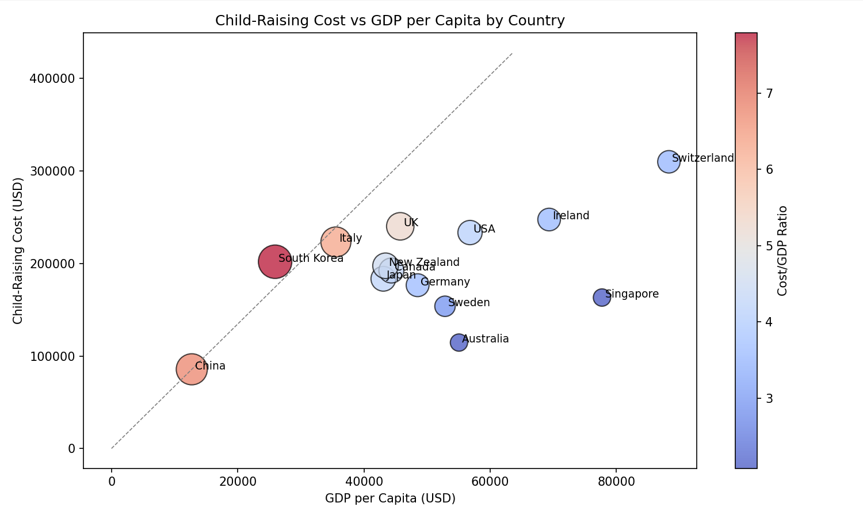

Reference:China Fertility Cost Report 2024;China Fertility Status Report, 2006-2016:An Analysis Based on 2017 China Fertility Survey

[J]. Population Research, 2018, 42(6): 35-45.

1. After diving into the insights of what happened in recent China, we find that the population has stopped growing and the population growth rate has dropped dramatically since 2017 and even reached negative growth in 2020. We then looked into the reasons behind it and find the low marriage rate and low fertility rate may play a role in it.

Finally, to verify the assumption and analysis above, we will build a model to analyze the relation ship between the population growth and marriage rate, age of first marriage, fertility rate, house price to income rate.

The result of regression is quite clear. The fertility rate is highly positive related with the change of population. In the regression model, the fertility rate is the most significant variable, which has a R square of 0.9421. Marriage registration is similar to fertility rate, but with a lower R square of 0.6026. This means that high fertility rate and marriage registration are likely resulting in a population boosting. However, there is negative impact of house price to income ratio on population change, which turns out that a heavy house burden is negative to population growth.

